**ASP Web API Get Method with parameters-Json**

Create an Api controller called CoursesController. Add a Get method with a parameter called courseName and of type string and method will return course detail based on the course name

Create a Model class in models folder as Course.

Create a static list of courses as given in the screenshot. Courses List:

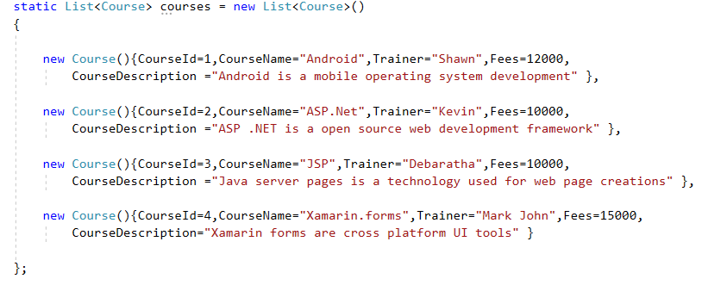

Get method return type should be ‘HttpResponseMessage’. If the course name is present in the list of courses, display the course detail. No course name is present display message ‘Course Name not found’. Display the course detail in json format in browser.

**Sample Output:**

**The Url in browser will be** http://localhost:63584/api/Courses?coursename=asp.net

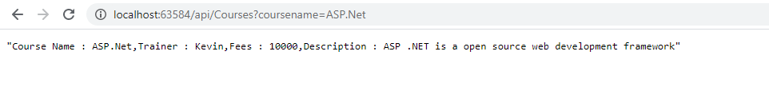

**The Url in browser will be**

http://localhost:63584/api/Courses?coursename=ASP MVC

